

***SCHOOL OF MECHANICAL AND MANUFACTURING ENGINEERING (SMME)***

**AE – 01**

**ENGINEERING DRAWING (AE – 103)**

**ASSIGNMENT NO. 02**

**NAME: ATEEQ – UR – REHMAN DATE: 10TH MAY 2024**

**CMS ID: 465502 SEMESTER: 2ND**

**INSTRUCTOR: MS. LAIBA WAHEED**

**INTRODUCTION:**

Engineering drawing is a vital language for engineers, enabling precise communication through visual representations. AutoCAD, a powerful computer-aided design (CAD) software, plays a crucial role in creating accurate drawings. In this assignment, we explore how AutoCAD facilitates the production of **orthographic projections,** which provide detailed front, top, and side views of three-dimensional objects. Additionally, we discuss the significance of mastering both orthographic and **isometric drawings**, which offer a pseudo-three-dimensional perspective. AutoCAD streamlines this process, allowing engineers to transition from conceptual design to practical implementation seamlessly.

**TOOLS:**

The following tools and features of AutoCAD were used to draw the projections of the drawings

1. Line tool
2. Circle tool
3. Mirror tool
4. Center-line and Center-cross/marks
5. Fillet tool

Additionally, the properties of these tools, when used in the drawings, were changed accordingly to match the view of the projections i.e. the lines were made to be solid and hidden, and denoted with different colours to differentiate them

**DIMENSIONING**:

Dimensioning was done using modifying the default style using the DIMSTYLE command for dimension and extension lines, along with text height and colour and arrow head style, offset and colour.

**PICTURE 1:**

Blueprint:

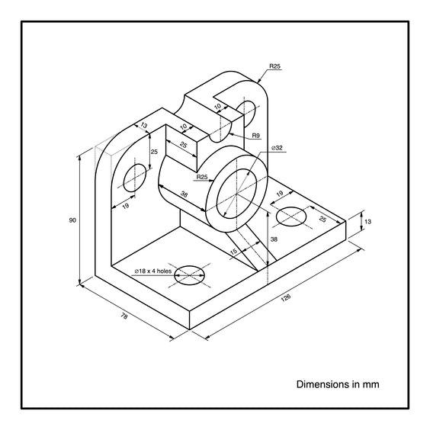

AutoCAD:

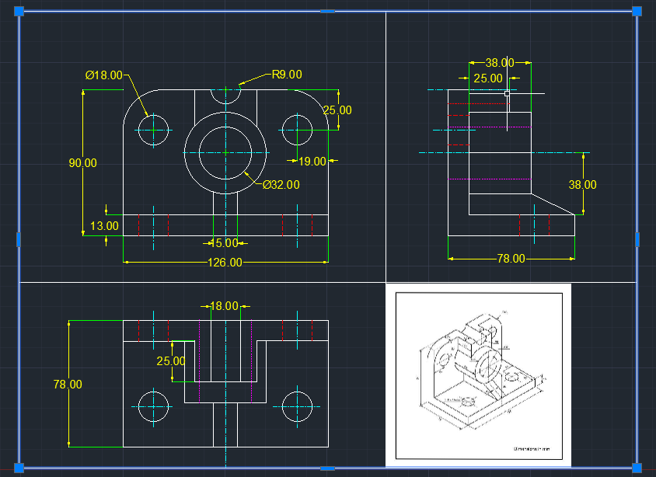

**PICTURE 2:**

Blueprint:

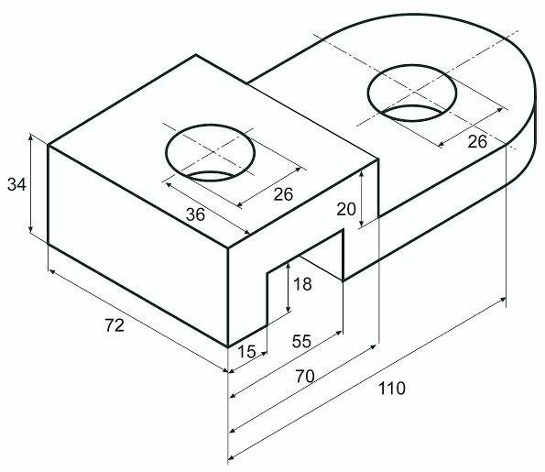

AutoCAD:

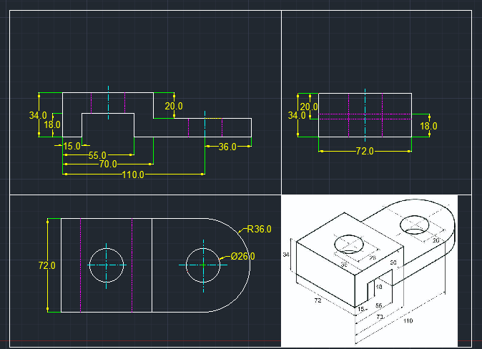

**PICTURE 3:**

Blueprint:

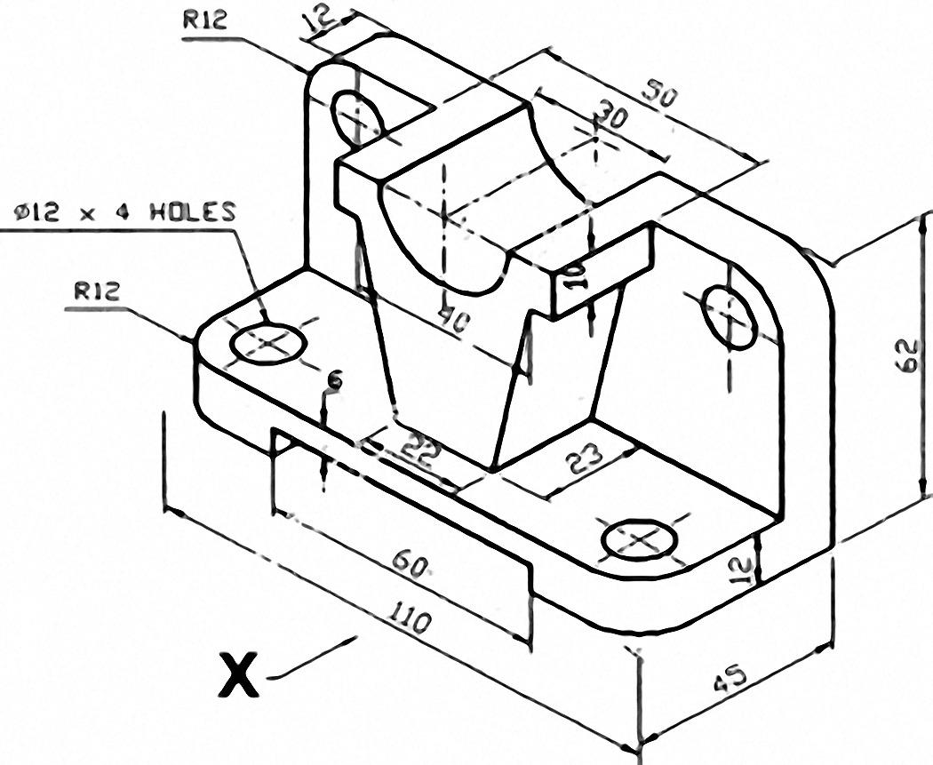

AutoCAD:

